Southern Tier Chapter of
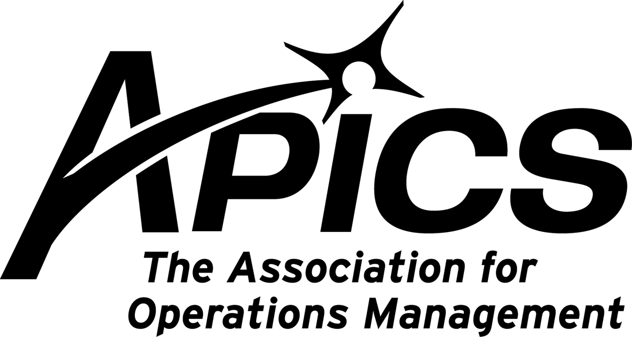

“Advancing productivity and innovation and competitive success.”

NO OCTOBER DINNER MEETING

Southern Tier Chapter Tours Endicott Interconnect

On Wednesday, September 16th Endicott Interconnect (EI) in Endicott, NY hosted a tour of their North Street facility for the Southern Tier Chapter of APICS. EI originally was a part of IBM and has been in the business of advanced PC Board manufacturing for over 40 years. The division was sold to private local interests in 2002. Since then EI has continually enhanced their technology and is now a world class supplier of advanced electronic packaging and mechanical equipment specializing in fabrication and assembly of complex circuit boards, flip chip and wire bond semi-conductors for applications in defense, computing, communications, and medical devices.

Prior to the start of the tour John Shearer, Materials Manager of the Complex Products Division, gave an overview the EI operation and some of the history of the business. The two hour tour covered the panel manufacturing and complex assembly areas. It is evident that EI has invested heavily in the equipment required to compete in the advanced manufacturing of these high tech products. The tour guides directed us through the areas where the laminated circuit boards are manufactured, machined, plated, and assembled. Their commitment to quality was evident with in process inspection steps supported by laser precision optical measurement systems. It is a very impressive operation.

We thank Jennifer de Souza, John Shearer, Ellen Gerhart, Mike Cummings, Mike Vincent, and Terry Allen of EI for taking the time to arrange and conduct the tour.

Congratulations to our own Don Sheldon, CFPIM, CIRM, CSCP, who has been selected as an APICS Functional Committee Chair for 2010! Don will be the Body of Knowledge – Professional Development Committee Chairman. This committee oversees the Operations Management Body of Knowledge, which helps us understand the language, best practices, and techniques that help APICS professionals to succeed.

APICS News from Don Sheldon, Vice President of Education

CSCP – Hope all of you have had a good summer. The economic situation has made it challenging for many, I know. We still want to hear from people who have interest in the CSCP course. To date we have been unsuccessful at getting a minimum class size. Please let me know if you are interested. This includes previous interested parties as I know many things have changed since our last correspondence in the spring.

CPIM – There are seats left in the CPIM courses offered this fall.

- SMR, the last in the 5-class CPIM series is being offered at BCC on Tuesday evenings starting 22 Sept. Contact Dave Gardner, the instructor dgardner@akraturn.com to register. Normal pricing applies which is $450 plus book price of $85 for members. Non-member class registration is higher to cover the membership fee.
- Basics, the first class in the 5-class CPIM series is starting on Monday afternoons 2:30-5:30 pm at BCC. Normal pricing applies which is $450 plus book price of $85 for members. Non-member class registration is higher to cover the membership fee. Contact dsheldon@sheldoninc.com to register or for more information.
- MPR, class 2 in the CPIM series will also be held starting in January at BCC. More to follow.

I will be leaving the Board of Directors – After several years of local Southern Tier APICS Board of Directors involvement I am resigning at the end of the year. I have accepted an appointment as the National Committee Chair for APICS OMBOK (Operations Management Body of Knowledge). As I understand it, it is a requirement that national committee members can not serve on local APICS boards. I do still plan to be involved with the Board in a “past president” role which is a non-voting role. It has been a rewarding experience and I look forward to keeping involved with the local chapter and my local friends and to making new friends in Chicago. I will stay in touch!

The Southern Tier chapter wins Silver award for C-BAR! 

At the risk of dislocating our shoulder from patting ourselves on the back, your Southern Tier chapter has been awarded the Silver level for C-BAR. What is that, you might ask?

C-BAR stands for Chapter Benchmarking and Reporting Program. It’s APICS’ way of assuring that each local chapter meets certain minimum standards. The chapters are measured against a set of standard criteria. Those who excel – such as our chapter – win awards. Think of it as APICS’ form of quality control; it ensures that the Board of Directors promotes local educational opportunities and does not take a vacation to Aruba with your membership dollars.

Award levels are Bronze, Silver, and Gold. This year Silver wins a $75 gift certificate for the chapter at the APICS bookstore, as well as recognition in the APICS Leadership Central newsletter and on the APICS website.

If you have any questions about the C-BAR program, please contact Lee Schechter at lschechter@stny.rr.com.

APICS extends membership for the recently unemployed
Did you know that you don’t have to give up your APICS membership if you lose your job? APICS members who are temporarily unemployed and actively seeking work within the operations management business sector can request a one-year extension of their membership at no cost. This is an increase from the previous six-month extension. Members submit their completed form to STAPICS local chapter president Dave Gardner [dgardner@akraturn.com] for approval. The chapter president submits the completed form to APICS Headquarters for processing. Students, retirees, and buy-out participants are not eligible.

Go to the APICS bookstore at and request stock #01080. (the leading zero is required.)
http://www.apics.org/APICS/Bookstore/ProductDetail.aspx?CS_ProductID=219&CS_Catalog=APICS+Bookstore


Your 2009-2010 Board of Directors

President & Acting Education Director Dave Gardner dgardner@akraturn.com
Past President Don Sheldon dsheldon@stny.rr.com
Secretary Deb Unkel deb.unkel@raymondcorp.com
VP Membership Lee Schechter lschechter@stny.rr.com
VP Programs Michael LoSapio mlosapio@visualtechgroup.com
Executive VP /Director of Finance Steve Whited sjw6@meadwestvaco.com
Web site Michael LoSapio mlosapio@visualtechgroup.com
Publicity / Marketing Kelly Noreika Kelly.noreika@lcmo.com

Southern Tier APICS
PO Box 1107
Binghamton NY 13902-1107

